

**Bachelor of Information Technology**

Software Development Methods – SD6503

**Semester 1, 2020**

**Testing and Secure Coding**

**Grey-box Testing(Unit Testing) & Sample test**

**Cathy Chen - 20603622**

**Yushi Huang - 21802429**

**Yuxi Wang – 22001587**

Table of Contents

Test Description 2

Class: controller 3

CustomersController 3

Coding 3

Result 4

DirectorsController 5

Coding 5

Result 6

MoviesController 8

Coding 8

Result 9

# Test Description

In Unit Testing, the test is done by comparing the expected result with the actual result. The test will create some new test data, such as variables, objects, lists, and so on. These new data will be used to create the expected results and input into the associated methods to make the methods run and get the actual results.

If the actual value is not the same as the expected value, it means that the test does not pass, and the same means that it passes.

# Class: CustomersController

## Coding

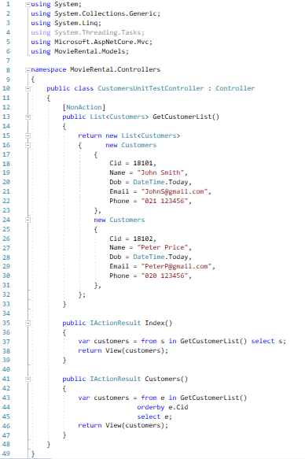

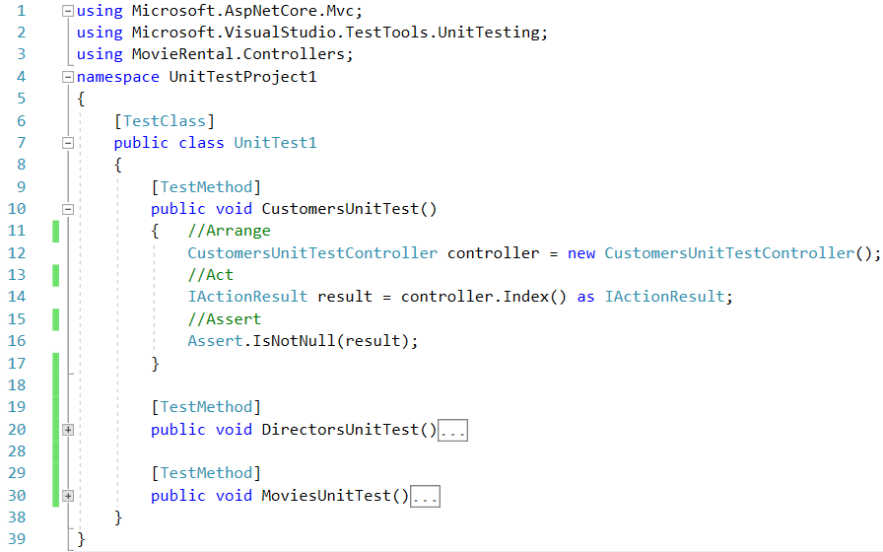

## Result

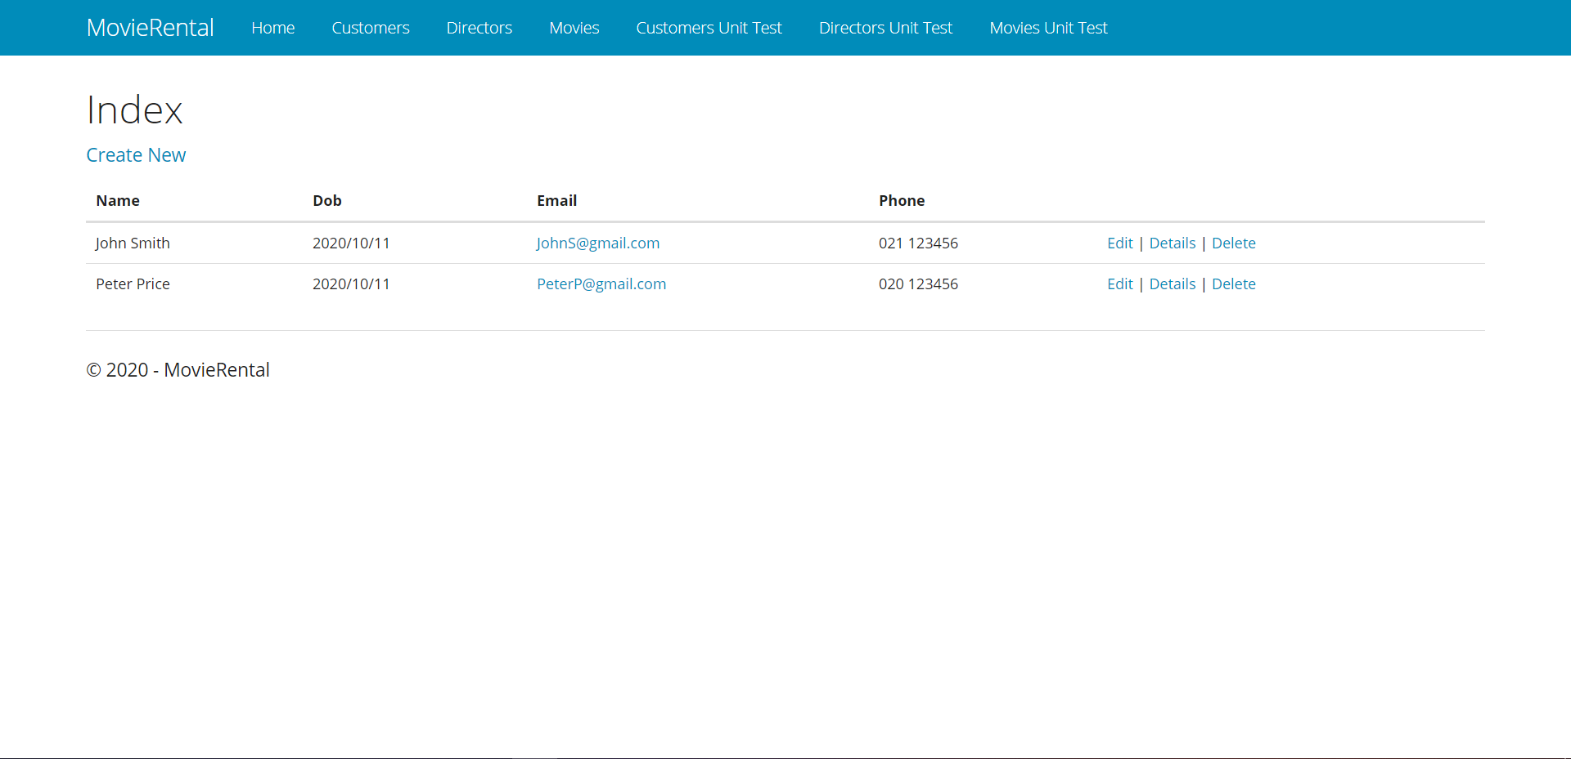 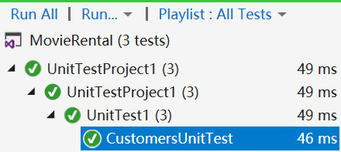

# Class: DirectorsController

## Coding

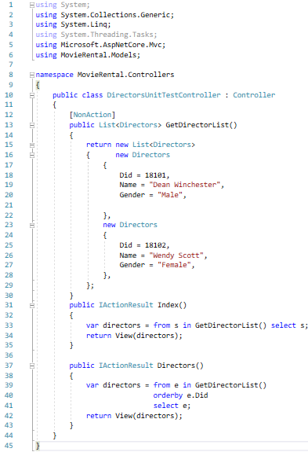

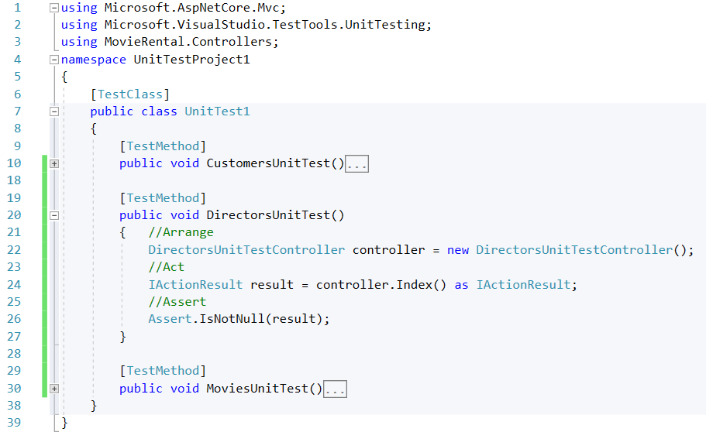

## Result

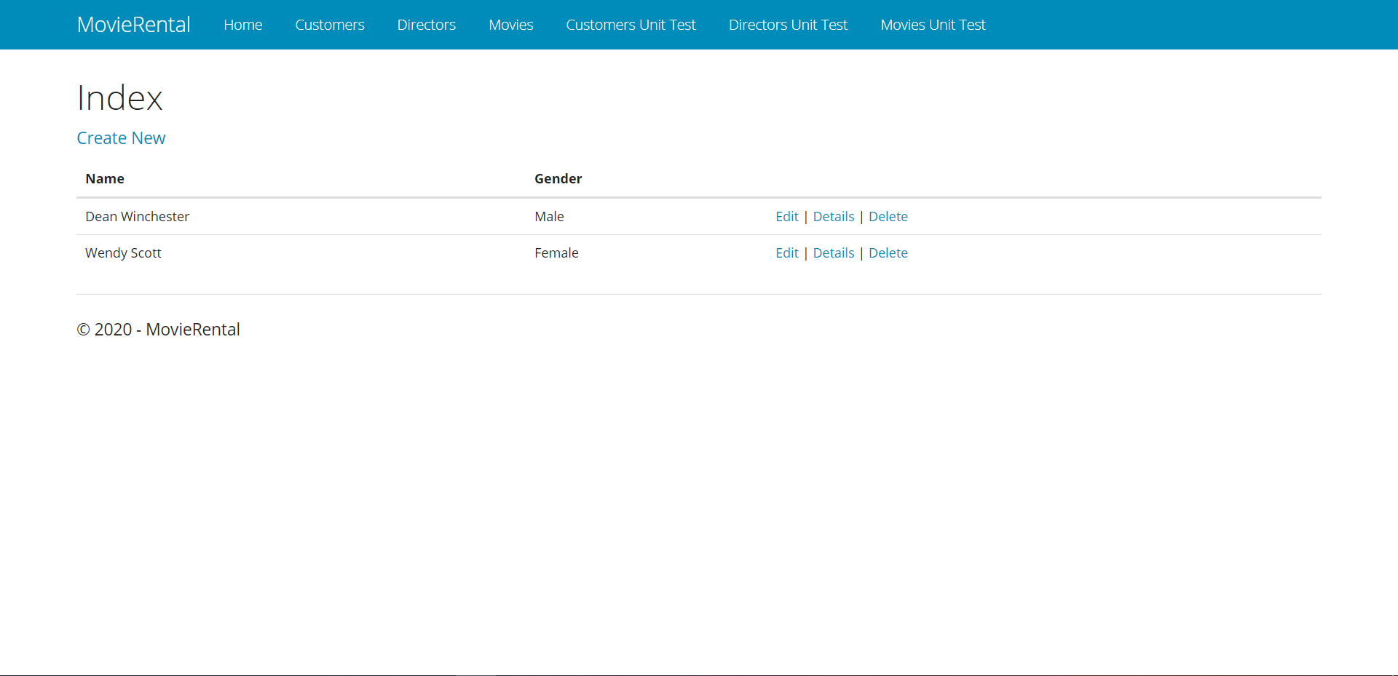

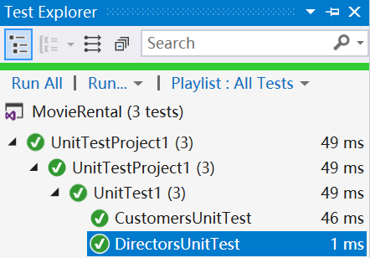

# Class: MoviesController

## Coding

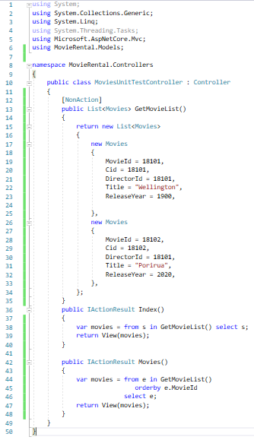

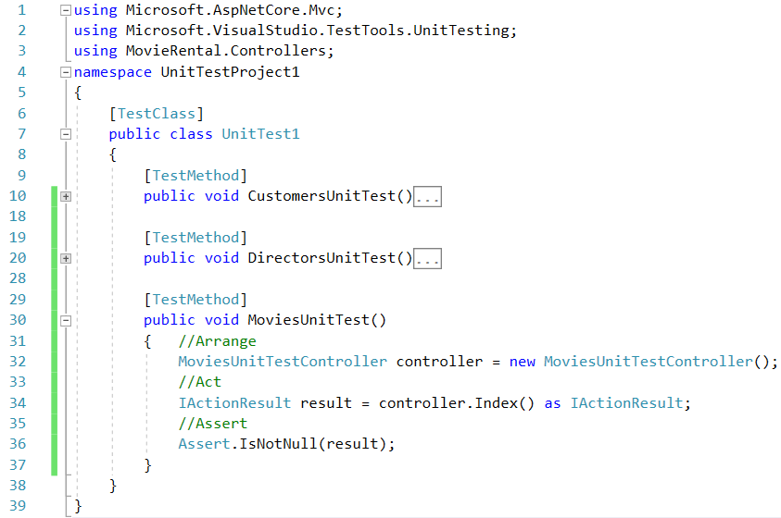

## Result

